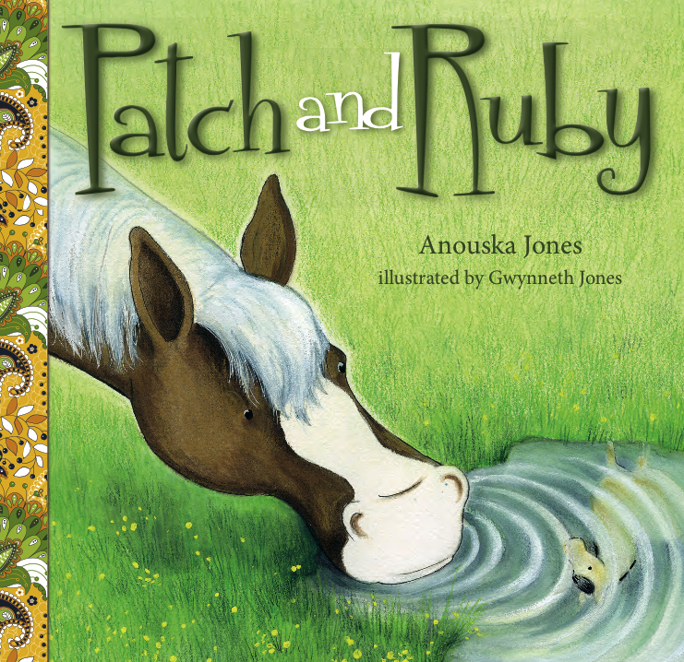
Patch and Ruby
Author: Anouska Jones
Illustrator: Gwynneth Jones
Publisher: EK Books
Price: $19.99
ISBN: 978-1-925335-22-4
Publication Date: October 2016
Audience: Children aged 4–8

Type of Text
Picture book

Key Curriculum Areas

English
Health

Themes

Friendship

Notes prepared by
Anouska Jones, Gwynneth Jones & Sally Fawcett

These notes may be reproduced free of charge for use and study within schools, but they may not be reproduced (either in whole or in part) and offered for commercial sale.

Copyright © EK Books

SYNOPSIS
Patch the pony is lonely. He has fun with his young owner, Sam, and the other farm animals are friendly, but sometimes it feels as if he still doesn’t quite fit in. Then one day Sam has an idea and something happens that changes Patch’s life forever.

Patch and Ruby is a heart-warming and often very funny tale about friendship and finding out where you belong

AUTHOR/ILLUSTRATOR BACKGROUND
Anouska Jones is a publisher, editor, book reviewer and writer. She is the Publisher for Exisle Publishing and EK Books, and is the Senior Editor of children’s literature website Kids’ Book Review. She lives on her rural property with her husband and daughter, three horses, eight chickens, three ducks, two dogs, one cat and one budgie.

Gwynneth Jones drew all through her maths book at school, so left to study art at TAFE and then majored in Plant and Wildlife Illustration at the University of Newcastle. Since then, Gwynneth has been imagining and drawing madly, exhibiting and holding market stalls, and creating picture books. She is the illustrator of the very successful Don’t Think About Purple Elephants (also EK Books).

ILLUSTRATION STYLE
The illustrations are whimsical and emotive with a colour palette of greens and browns, earthy colours that come from a rural setting.

SELLING POINTS

- A gentle story for ages 4–8, touching on themes of friendship and belonging.
- Can be linked to the Health curriculum to assist students to learn strategies for making friends.
- Relates to the common early childhood classroom theme of ‘Farms’.
- Classroom activities provided across curriculum areas of English, Mathematics, Health and Art.
- Also available as part of a boxed set of three books, The Sugar & Spice Collection.

AUTHOR/ILLUSTRATOR INTERVIEW
1. What was the inspiration for the story?
The author, Anouska Jones, lives on a small rural property and has three horses of her own. The story was inspired by her experiences with two of her horses (the ‘real’ Patch and Ruby), and watching her young daughter’s interaction with them. Anouska also used to volunteer at a centre that worked with horses as therapy animals for children on the autism spectrum and saw first-hand how animals, and horses in particular, can allow children to relax, open up and connect with others. This served as added inspiration for incorporating horses into a story about finding a place in the world where you can feel comfortable to be yourself.

2. What was the most rewarding part of this project?
A: Seeing Gwynneth work her illustrating magic and bring my characters to life.
G: Doing a book for my publisher … very flattering.

3. What was the most challenging part of this project?
G: Getting the patches and face on Patch to look similar on all the pages! I drew a template of Patch facing left and right so I could remember which side the mane was on with what patches.

4. What media did you use to create your illustrations? Can you briefly describe your process?
G: I used gouache (an opaque watercolour) for the ponies and colour pencil on top for Patch’s coat, watercolour pen for Ruby and on Ruby’s mane. I used black gel pen on Patch’s mane to make the lines with shadow. I often use gouache if I really want something to stand out, like the chickens’ combs.
My process is to first produce the roughs in pencil, which is my favourite part of book creating, then after approval from my editor and book designer, I use my light table to trace my roughs in pencil, then to start the colouring in. Sometimes I use regular watercolour, then build upon that with either colour pencil or gouache, but if I make a big mistake and can’t fix it, I start the whole illustration again. I have also used Posca pens as well; I will use any media that works for what I want to do.
TEACHING NOTES

- Before Reading
    - Show the cover to the class and ask the students what they think the book might be about.
    - Read the back cover blurb. Does this give them more of an idea of what the book could be about?

    - During Reading
    - Read the book through once continuously.
    - On the second reading ask questions as you go to develop children’s comprehension skills (see BLM 1 for discussion questions)

    - After Reading
    - See curriculum ideas for after reading activities.

Curriculum Ideas:

ENGLISH

Classroom ideas:

- Oral language discussion questions. (See BLM 1)
- Write thought bubbles for Patch and Ruby, What do you think they were thinking when they first met? (See BLM 2)
- Write a book review. (See BLM 3)
- Reading Comprehension. (See BLM 4)
- Sequencing activity: Order the actions of Patch and Ruby’s first meeting. (See BLM 5)

HEALTH

Classroom ideas:
- Think/Pair/Share:
Think about a time you have felt lonely.
How did it feel?
What did you do?
What made you feel better?
- Role-play the meeting of Patch and Ruby — what did they do? (See BLM 5)
- Brainstorm what you can do when you meet someone new? (See BLM 6)
- Have students write down the things they might do when meeting a possible new friend.
(See BLM 6)
- Role-play meeting a new friend — what would you do?

THE ARTS

Classroom ideas:

VISUAL ARTS:

- Drawing — horses
Google images of horses or look in books.
Brainstorm the features that horses have. (Pointed ears on top of head, long nose, big nostrils, round bottom, long tail, 4 legs, hooves, mane.)
Students have a go at drawing their own style of horse including all these features.

- Drawing — Farm animals
Source some model farm animals. On a sunny day place a farm animal in front of a piece of paper so the shadow falls on the paper. Students trace around the shadow.

