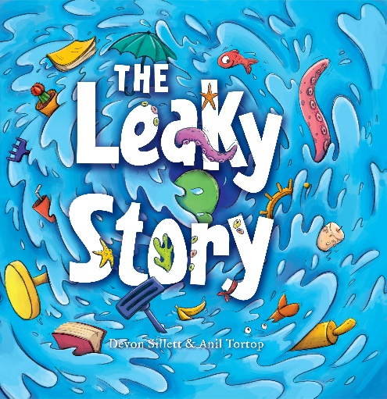
Type of Text
Picture Book

Key Curriculum Areas
English
Visual Art
Drama
Music

Themes
Imagination
Family
Togetherness
Exploration
Reading and books

The Leaky Story
Notes Prepared by
Devon Sillett

These notes may be reproduced free of charge for use and study within schools but they may not be reproduced (either in whole or in part) and offered for commercial sale.

Author: Devon Sillett
Illustrator: Anil Tortop
Publisher: EK Books
Price: $24.99
ISBN: 978 1 925335 39 2
Publication Date: April 2017
Audience: Children aged 4–8
Synopsis

A book sits abandoned on a living room shelf. While the Blossburn family happily gets on with other things like watching TV and playing video games, the book aches to be read. The longer it sits abandoned, the more it aches. At last the book can’t take it any longer. Slowly it starts to swell. Then it starts to leak! At first it’s only a small trickle, but eventually the Blossburns can no longer ignore the octopus, crabs and other marine life that are swirling around their suburban home. And when pirates sail out of the book, the family must band together to reclaim their living room. Can J.J. and his parents find a way to get the characters back in the book? And in the process, will they discover that sometimes books are the best fun of all? The Leaky Story is an action-packed adventure into the wonderful world of books, the power of the imagination, the art of storytelling and the importance of family.
Copyright © EK Books
AUTHOR BACKGROUND
Devon is an author and sessional academic, a former radio producer, and a mother of two. She loves all things kidlit, and has a penchant for metafiction. Currently, she is researching Australian children’s picture books for her PhD at the University of Canberra.
The Leaky Story is Devon’s first picture book, with another soon to follow, also with EK Books. She holds a BA Arts (Eng, Language Lit), a BA Communications (Journalism), a Grad Dip Ed (Secondary English), and an Honours degree (focusing on feminism in YA Speculative Fiction). For her Honours thesis, she was awarded the prestigious APA scholarship.
Devon lives in Australia’s picturesque capital, the ACT.
If you would like to find out more, please follow her on her facebook page: www.facebook.com/devonsillettauthor.

ILLUSTRATOR BACKGROUND
Anil Tortop was born and raised in Turkey, moving to Australia in early 2011. She’s been trying to get used to the local eight-legged house intruders and slithering visitors ever since! As well as illustrating books, Anil also works as an animator and character/concept designer. She lives with her husband in Brisbane. In their small home studio together, they call themselves ‘Children’s Booksmiths’.
More information about Anil is available on her website: www.aniltortop.com

SELLING POINTS
- An exciting and imaginative story about the benefits of reading.
- Encourages family time.
- Encourages children to revisit favourite books that might have been forgotten, and perhaps find some new ones too!
- The illustrations are vivid and exciting, yet detailed and thoughtful.
- Each page aims to stimulate the imagination, and encourage children to let loose and explore their own!

AUTHOR INTERVIEW:
- What was the inspiration for the story?

I wanted to write a story that encapsulates the excitement and wonder that books have to offer. After the birth of my first son, I realised there was no guarantee that he would love books as much as I do – every person is so different, even mother and child! Ultimately, I can only guide and encourage him towards a love of books. Still, there are entire worlds in books just waiting to be unlocked and explored. I wanted to write just such a story – one that children would be enthusiastic about and want to read time and time again.

- What was the most rewarding part of this project?

I really cannot name just one aspect. For starters, I have to mention Anil’s illustrations. She breathed life onto the page. Her grasp of colour, fun, and vivaciousness is awe-inspiring. Truly, her perspective on the manuscript is nourishing to the soul! Seeing that my manuscript managed to elicit such incredible artwork floored me.

Also, when I read this book to my son as part of our regular nighttime routine, he was riveted to the page. He loved it and wanted me to read it again. I have to say, that was beyond rewarding. That made my year!

- What was the most challenging part of this project?

Getting it just right. Picture books allow for so few words, so the ones that are chosen have to be absolutely perfect in order to convey the right rhythm, atmosphere, build-up and conclusion. Conversely, picture books do afford writers the luxury of writing twenty(plus) drafts, whereas that is a near impossibility for novels.

ILLUSTRATOR INTERVIEW

- What was the most rewarding part of this project?

I love it when the story has a lot of room for the illustrations. There were unlimited options for me to add some background stories that are not written in the story. The most enjoyable part was the octopus and its relationship with Mr. Blossburn. I like the parrot’s participation too. Lots of fun! I’m not sure why, but the most challenging part was to draw the vacuum cleaner wand! That’s why I had it on my desk for a while, not as a decoration. :)

ILLUSTRATOR STYLE

I tried to convey the energy level in the story using dynamic lines, poses and compositions. I also worked on the characteristics a lot. Each of them should have different personalities and their body languages and facial expressions should behave accordingly.

TEACHING NOTES

English:

- The book in The Leaky Story starts to leak. Can students think of other ways that books might try to grab their attention?
- Ask students if they can identify the beginning, complication and resolution in the story.
- If students could jump into any story they have read, and bring their friends or family, which story would they choose? Why?
- Choose your favourite double page spread. What do you like about it? What would you change about it?
- What messages do you find in the pictures that you can’t find in the accompanying words?
- Ask students if books are important. Why or why not? What are the differences between books and other sorts of technology available such as computers, phones and iPads. What are the pros of each? What are the cons?
- Using your list of pros and cons, imagine that you are the book in The Leaky Story. Write a note to the Blossburns about all the reasons they should pick you over other entertainment options.
- Organise a debate about books versus e-readers.
- Do you like J.J? Why or why not?
- If you were Mr. and Mrs. Blossburn, how would you react to finding the story leaking into your living room?
- Why don’t Mr. and Mrs. Blossburn believe J.J. when he tells them that there is a story leaking into the living room? What hints does the story give us about this?
- ‘Drip’, ‘Drop’, ‘Plop’, Splish’ and ‘Splash’ are examples of onomatopoeias. Onomatopoeias are words that sounds like their meaning. For example, ‘buzz, purr, boom’. Can you think of five more examples of onomatopoeias? Which one is your favourite?
- What makes the pirates, kraken, octopus and other intruders disappear back into the story? How do we know this?
- The last page shows the Blossburn family going on a safari together. What does this show us?
- Write a story called ‘The Hungry Story’!
- Write a story called ‘The Pirates’ Great Escape!’ The story is about the pirates who have lived in a book their whole life and suddenly find themselves in an ordinary suburban living room.
- Write your own story with the beginning sentence, “The book sat. And sat. And sat.” Make sure the story includes a beginning, complication and resolution.
- Write a different story that ends with “Perhaps we should go on another!” Make sure the story includes a beginning, complication and resolution.

Visual Art:
- In The Leaky Story, a book about acquatic adventures sits abandoned on the shelf. Eventually, it starts to leak out into the Blossburns’ livingroom. Imagine that your favourite book was trying to get your attention. What would that look like? Draw an exciting scene from this imagining.
- Paint/draw/make a collage depicting what your family would look like battling pirates!
- Illustrate the most unbelievable yet true thing that you have ever experienced.
- Draw an abstract painting that represents the emotions the book must have felt as it sat abandoned on the shelf.

DRAMA:
- In groups, act out The Leaky Story. One person will be the narrator, one will be J.J. and one for each of his parents, Mr. and Mrs. Blossburn.
MUSIC:
- Drip, Drop, Plop, Splish, Splash! Beautiful music can be made from the sounds of everyday things. In groups, can you compose a song with found objects?

