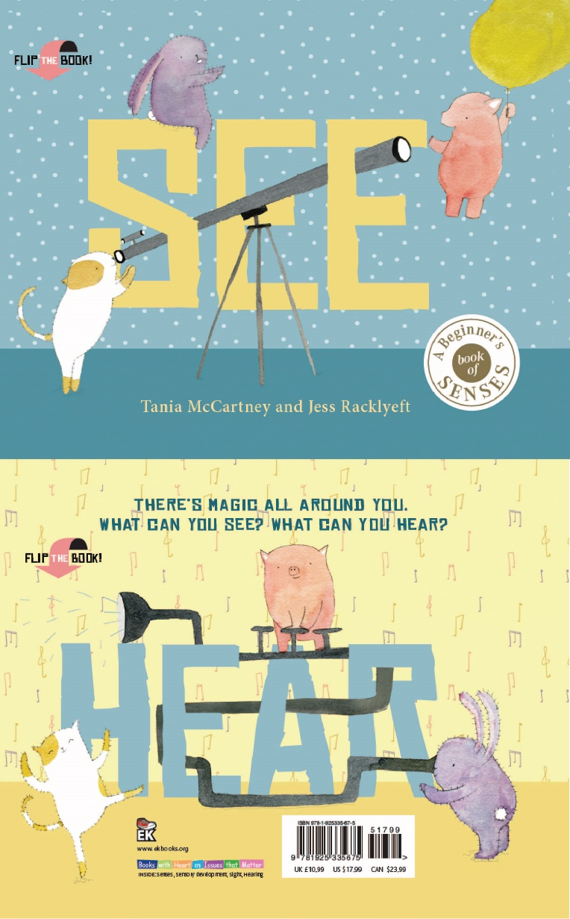
See Hear
Author: Tania McCartney
Illustrator: Jess Racklyeft
Publisher: EK Books
Price: $19.99
ISBN: 9781925335675
Publication Date: April 2018
Audience: Ages 3 – 8

Type of Text
Picture book

Key Curriculum Areas
English
The Arts
Health

Themes
Senses
Friendship
Love
Imagination
Animals
Kindness

Notes prepared by
Tania McCartney and Jess Racklyeft

These notes may be reproduced free of charge for use and study within schools but they may not be reproduced (either in whole or in part) and offered for commercial sale.

Copyright © EK Books
SYNOPSIS

There’s magic all around you. What can you see? What can you hear? See Hear invites us to open our eyes and ears to the everyday magic around us.

This innovative flip-format picture book is a sequel to the best-selling SBCWI Crystal Kite 2017 winner and CBCA Notable Book for 2017, Smile Cry. Piglet, Bunny and Cat return in a charming, whimsical sensory adventure that encourages kids to explore the multitude of ways they can engage with the world around them, particularly via the senses of sight and sound.

From watching 'squiggly rain' on a window to pointing out 'heavenly horses' in the clouds, from hearing 'buzzing blossoms' as bees collect pollen to 'hot pan sizzles' as a favourite meal is prepared, See Hear invites us to open our eyes and ears to the everyday magic that surrounds us.

Younger kids will respond to the soft whimsical illustrations, while older readers will enjoy the onomatopoeic wordplay. Perfect for ages 3 and upwards, this is a book that will captivate children and parents alike.

AUTHOR BACKGROUND

If she could, Tania McCartney would live inside a book. As an author, illustrator and editor—she kind of already does.
Tania has written for both children and adults, and has been shortlisted and awarded for published and unpublished works. As the Founder of Kids’ Book Review and an ambassador for the ACT Chief Minister’s Reading Challenge, she is mad for juvenile literacy. She’s also mad for illustration and that’s why she founded the enormously successful 52-Week Illustration Challenge, where she met See Hear illustrator Jess Racklyeft.
An experienced magazine writer, editor and speaker, Tania has many years’ experience in book design and has a deep love of illustration. Australia: Illustrated, her first self-illustrated picture book, was released in November 2016, and she is now illustrating even more than she is writing.

Tania has lived in Paris, London and Beijing, and currently lives in Canberra with her family, a forest of artwork and a mountain of books. www.taniamccartney.com

ILLUSTRATOR BACKGROUND

Jess Racklyeft has been a book nut since a young age. After finishing a degree in Communications, she began working in publishing – sales! While learning a lot of the behind the scenes operations of the book world, it wasn’t until the birth of her daughter in 2012 that she had the courage to try her dream job of illustrating books rather than selling them.

Since then, she’s worked on (or is working on) ten picture books, along with greeting card designs, client projects, portraits and prints for her Etsy shop.

Now with two young children, she’s either reading, drawing, going to the local bookshop story time, or occasionally trying to write picture books. It’s a busy but blissful time, and the happiest moments are spent drawing in her Melbourne studio, often with her five-year-old joining in beside her.

ILLUSTRATION STYLE
Watercolour, pencil and digital pattern/collage create a soft, quirky, modern yet whimsical illustrative style.

SELLING POINTS
- A book that will appeal to the very young due to its animal characters and whimsical, pastel illustrations, but would also appeal to older children, for the cuteness, humour and more sophisticated text.
- A wonderful resource for early childhood and school settings, where the senses are an important part of both play and learning.
- See Hear is a unique take on the senses concept book, with an episodic narrative that takes children on a journey through the senses, in real-life, everyday happenings children can deeply relate to.
- The use of onomatopoeia in the Hear side of the book, invites children to participate with the story.
- The book is particularly striking for its flip-the-book concept—essentially two books that meet seamlessly in the middle.
- The author and illustrator have become a well-known team, producing award-winning books for little ones.

AUTHOR INTERVIEW

1. What was the inspiration for the story?
See Hear was a natural follow-on to Smile Cry, which was so warmly embraced by adults and children. I couldn’t help but revisit these gorgeous animals—Cat, Rabbit and Bunny—in another important setting for very young children… a focus on the senses.

Like emotions, the senses are never black and white. They are multiple shades of grey. And how we see and hear things can vary enormously, depending on who we are, our background, life experience, and where we are standing in the world. Children are no exception, and I believe there is a generic misconception that very young children can’t absorb the nuance and visceral connection to the different ways we see and hear the world around us.

It’s also important to me to affect adults with the books I write. In See Hear, the various scenes will send most adults winging back to early childhood and the tactile, real-life nature of our sensory experiences. That lovely sense of wonder, innocence and delight is something adults really need to reconnect with in our current virtual existence.

2. What was the most rewarding part of this project?
Exploring senses from a child’s POV was so much fun. Watching Jess’s illustrations unfold is a continual delight. And sorting through the onomatopoeia is just the most delicious thing. What is it about pops and whooshes and crackles? No wonder kids love this sort of thing.

3. What was the most challenging part of this project?
Nothing. Our little team, Jess, publisher Anouska, graphic designer Mark, and me—we are tight. Our projects are seamless and organic and a real joy.

ILLUSTRATOR INTERVIEW

1. What media did you use to create your illustrations? Can you briefly describe your process?

Like Smile Cry, these illustrations were created with watercolours and a few digital tweaks. I tried to use a very similar palette, and of course the same round little characters.

2. What was the most rewarding part of this project?

It was lovely and super easy picking up where we left off from Smile Cry, working with the same awesome team and getting to play with the same characters again. It was also extra rewarding knowing how well the previous book did to build on the style a little and experiment a little more.

3. What was the most challenging part of this project?

Sometimes it was slightly tricky trying to work out how to show sounds visually – for example, the turn of a page. Luckily the team talked through each illustration and we worked out the best visuals together.

TEACHING NOTES

ENGLISH

Classroom ideas:

- Read the story and have children choose a particular page they resonate with. When did they last spot a ladybird? What does breakfast cooking sound like in their house? Have children experienced any of these scenes?
- Depending on student age, either create a list or have children create a list of synonyms pertaining to seeing and hearing. Older kids could create sentences using these words.
- Ask children which side of the book they enjoyed most, and why. Have them elaborate as much as possible. What character do they resonate most with and why?
- Talk with kids about the format of See Hear and why it is different (a flip book, with two joining storylines). Ask them if they feel the centre page unites to two storylines, and how it manages to do this. You can incorporate the use of image and typesetting in this discussion.

THE ARTS

Classroom ideas:

VISUAL ARTS:
- Kids can draw a poster, split in two, showcasing the two senses—sight and hearing. Have them draw items they might be able to see and items they might be able to hear.
- Explore the function of the eye and sight by having children explore or draw a cross-section of the eye.

DRAMA:
- Have children explore onomatopoeia. What other ways can they say BANG? WHISPER? CRACKLE? Have them act out the words.
- Have students create sounds by using classroom objects. One child can create the sound behind a scene and other students can guess how the sound is being created.
- Play I Spy in the classroom, but mix it up by changing the clues around. Have kids think of three visual cues for the object they’re targeting. For example, ‘It’s pink, fluffy and cute’ or ‘It’s tall, shiny and you can open it’.

MUSIC:
- Children can write and perform their own songs. Using the tune and lyrics of an existing nursery rhyme, have them substitute certain words with onomatopoeia. The results could be very funny!

HEALTH

Classroom ideas:

- What do students particularly love seeing and hearing? What sights and sounds make them happy or sad or excited or afraid? Have kids share their ideas with the class.
- Talk about thunder and lightning, and how the site of lightning and the sound of thunder interplays. How do these two elements make kids feel?
- Explore sight and hearing disabilities by talking about the challenges some people might face. What would it be like to be blind or deaf? For older children, consider having children attempt simple (safe) tasks with their eyes closed or with noise-cancelling headphones on. Can they still communicate effectively?

SPECIAL CELEBRATIONS
The beauty and high production values of this book would make a beautiful newborn baby or christening gift.

For more information on the book, visit www.ekbooks.com.au/titles/see-hear

