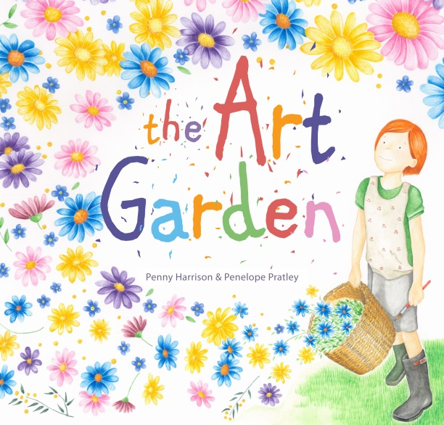
The Art Garden
Author: Penny Harrison
Illustrator: Penelope Pratley
Publisher: EK Books
Price: $24.99
ISBN: 978-1-925335-590
Publication Date: February 2018
Audience: Children aged 3–8

Type of Text
Picture book

Key Curriculum Areas
English
Health
Art

Themes
Friendship
Self-Belief
Resilience
Creativity
Nature
Individuality

Notes prepared by
Penny Harrison

These notes may be reproduced free of charge for use and study within schools but they may not be reproduced (either in whole or in part) and offered for commercial sale.

Copyright © EK Book

SYNOPSIS
Sadie wants to be a painter, just like her best friend, Tom. She loves playing with colour and finding shapes in unusual places. But whenever Sadie picks up a paintbrush she makes a big mess. Instead, she spends her time working in the garden or playing with Tom. It’s not until Sadie takes a look at things from a different perspective that she makes a big discovery about herself and her own creativity.
This is a whimsical story about friendship and finding our creative flair. It encourages children to explore different ways of expressing themselves and celebrates the importance of individuality and self-acceptance.

AUTHOR BACKGROUND
Penny Harrison is a children’s author, book reviewer, garden writer and lifestyle journalist. A professional writer for more than 20 years, she has contributed to a range of leading Australian magazines, newspapers, guides and books, writing about everything from raising toddlers to raising chickens. Penny lives in a rambling old garden, on the edge of the Yarra Valley, with her husband and two young children, where she loves filling the house with books, plants and music.
ILLUSTRATOR BACKGROUND
Penelope Pratley is an illustrator, writer and educator. She adores illustrated stories. Penelope’s delicate drawings, and paintings, are infused with wonder to capture the heart of small things. She currently spends her days creating charming images for clients, successfully ignoring the housework, eating chocolate freckles and teaching others to interpret their world through art. Penelope loves collecting pencil cases and is never short on treasures to fill them with. She lives on the North Coast of New South Wales with a surfer, an inventor, a ballerina, three greedy chickens, a fat rabbit, and a guinea pig named blossom that looks just like the one in The Art Garden.

ILLUSTRATION STYLE
Using watercolour paints and a soft colour palette, Penelope captures a world that children can relate to by portraying believable characters in an environment full of detailed and realistic elements. Throughout the book emphasis has been placed on creating many detailed objects within the environment for children to find. Penelope carefully looks at what she is going to paint and begins by making several pencil sketches to work out how the page should look. After she decides on the colours to use she begins painting in layers. The first layer is a wash, then the shadows are added and the details are layered until the finished image is achieved.

SELLING POINTS
- A gentle story for ages 3-8, touching on themes of friendship, creativity and individuality.
- Other themes include the importance of being true to oneself and the dangers of comparing yourself to others.
- Whimsical storyline engages children, with gorgeous illustrations in a vibrant and enticing palette.
- The second picture book from author and garden writer Penny Harrison, The Art Garden is the debut publication of exciting illustrator talent Penelope Pratley.
- Opportunity for discussions with children about the different creative activities they enjoy and the ability to shine in their own way.
- Strong gardening theme encourages children to connect with nature in a variety of ways.
- Interactive and engaging shared reading experience.
- Classroom use: Visual art—different artistic mediums, playing with colour and finding patterns in unusual places, emotive expressions
English—vocabulary, reading, comprehension
Health—self-belief, confidence, individuality
AUTHOR/ILLUSTRATOR INTERVIEW
1. What is the inspiration for this story?
Penny: One of my favourite places to visit is Sunday Reed’s Heart Garden (in the shape of a heart) at the Heide Museum of Modern Art, in Melbourne. I have always wondered if Sunday, a prolific and creative gardener who supported some of Australia’s most renowned artists, ever wanted to be a painter herself. As someone who always wanted to be a painter, but never had the patience to learn, I started thinking about all the different ways we express ourselves creatively – from sculpture and drawing to cooking and gardening.

2. What was the most rewarding part of this project?
Penny: Seeing the way it evolved, from a story scribbled out on scraps of paper while sitting in my car one day, to Penelope’s stunning creation of Sadie and Tom, and interpretation of the story, to the final layout and design.
Penelope: Firstly being asked to illustrate Penny’s heartfelt story and then watching each image emerge from the end of my brush. Watching my children read the book together was a moment I will treasure. Oh, and finishing all the flower petals was a very rewarding moment too.

3. What was the most challenging part of this project?
Penny: Letting Sadie become frustrated and upset with her attempts at painting. I love the idea that we can all paint and we can all draw. But, in the end, I do understand that frustration and impatience when things don’t turn out the way we want straight away.
Penelope: I guess the most challenging part of this project for me was getting over the fear that I may let everyone down if the illustrations I created weren’t good enough – a little bit like Sadie feels in the book when she worries whether her pictures will be as good as Tom’s.

4. What media did you use to create your illustrations? Can you briefly describe your process?
Penelope: Pencil was initially used to sketch the storyboard and work out the composition of each page layout. Once the page layouts had been approved by the publisher, a good copy of each image was created using watercolour paints. The outlines were completed using a fine brush before each area was filled with a light wash of colour. Once the washes were dry the shading was added and then all the details, working in a production line. For example all of the violets were painted on all the pages, all the blades of grass were added at the same time to keep the colours consistent. The very last thing I did was add all the dot eyes using ink.
TEACHING NOTES
Initial Reading - Whole Class
- Before Reading
    - Show the cover to the class and ask students what they think the book might be about.
    - What do the colours and the overall design tell them about the story?
    - Do the endpapers tell them anything further about the story?
    - What type of story do they think it will be?
    - Read the back cover blurb. What type of story do they think it will be now?

    - After Reading
    - Discuss the author's reason for writing the text and the message she wanted to convey.
    - Have children interview Tom and Sadie to find out how they felt at different stages of the story.
    - Talk about what art is and the different forms of creative expression.
    - Discuss particular interests and hobbies and ask children to consider how they like to express themselves creatively.

Classroom Ideas:
(BLM sheets could be laminated and used for small group activities or photocopied for individual use.)

ENGLISH
- Oral language and comprehension questions (See BLM 1)
- Reading comprehension multiple choice questions (See BLM 2)
- Writing a book review (See BLM 3)
- Sequencing Activities (See BLM 4 & 5)
- Brainstorming other words to be used (See BLM 6)
- Try creating an acrostic poem, using the words GARDEN, PAINT or CREATIVITY.
- Compose a poem about something that makes your ‘heart smile’.
- Identify and discuss choice of words and repetition in the text.
- Write a story about your favourite creative activity, or what being an artist means to you.

HEALTH
- Discuss how Sadie feels when she compares herself to Tom, or tries to paint. Talk about the activities that make her feel better.
- Discuss Tom’s positive response to Sadie’s painting (supportive, encouraging) and how this is shown in the illustrations.
- Brainstorm the individual activities/creative pursuits that make the students feel happy.
- Discuss the individual and varying talents of each student. Have them design their own garden, then pass it around and have other students draw a flower (containing a positive word about that student) in the garden.
- Brainstorm situations that have made the students feel frustrated and upset. Write them on cards. In small groups discuss the difficult situations on the cards and decide on actions that could improve the situation. Write or draw an action/outcome for the frustrating situation.

VISUAL ARTS
- Discuss Sadie’s discovery of patterns and pictures in unusual places.
- Turn different patterns or shapes into pictures.
- Create an image using daubs of paint in harmonious colours. Create a second ‘daub’ painting using complimentary colours. Review the work as a class. No two paintings should look the same demonstrating the theme behind The Art Garden that we can all be creative in our own way. Encourage students to focus on the colour in this exercise not creating shapes or pictures.
- Design your ultimate billy cart, like Tom’s, or create an illustration of your dream garden.
- Take your students on a nature walk to collect ‘treasures’, leaves, seeds, feathers and flowers. Provide students with a magnifying glass when they return to class so they can have a closer look at their found objects. Ask them to look for interesting patterns. Encourage them to draw them using coloured pencil and to draw them in black and white.

BLM 1
Oral Language & Comprehension Questions

Page Turn | Questions | Check
1 | What is Sadie’s dream?
2 | How does Sadie play with colour?
3 | How do Tom’s paintings make her feel?
4 | What is she worried about?
5 | Why is she frustrated with her painting of a flower?
6 | Why do you think Tom hangs Sadie’s painting of a cake?
7 | List some of the things that make Sadie happy?
8 | Do you think Sadie enjoys painting? Why?
9 | What are some of the words used to describe the way Sadie paints?
 | Do you think these are positive or negative words? Why?
9 | What does Sadie think about when she climbs her tree?
10 | What does the word ‘wailed’ mean?
11 | Looking down at her garden, what does she realise?
12 | What’s different when Sadie picks up the paint brush the fourth time?
13 | What does the word ‘clambered’ mean?
14 | What does it mean when Sadie’s heart smiles?
BLM 2
Reading Comprehension (multiple choice)
- Sadie loves playing with …
- The guinea pig
- Colour
- Seeds

2. When Tom paints, Sadie’s heart …
- Aches
- Dances
- Smiles
3. Sadie screws up her painting of a cake because …
- It’s the wrong colour
- It looks like a mud pie
- It looks like a flower
4. Sadie climbs her favourite tree because…
- She tripped on the easel and is upset.
- She is angry with Tom.
- She is afraid of the guinea pig.
5. When Sadie looks down at her garden she sees it …
- Needs weeding.
- Is like a work of art.
- Is very colourful.
5. Sadie plants forget-me-nots because…
- She needs to remember something.
- She likes the colour.
- Tom will always be her best friend.

Book Review BLM 3

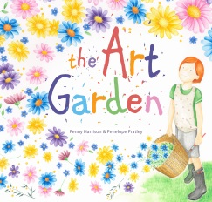 Title: ___________________________________

Characters: | Setting:
What happens in the story?

Did you like the story? Give it a score out of 5 stars.
Draw a picture on the back of this page.

Sequencing Activity BLM 4
Cut out and order the sentences.

Sadie tries to paint a flower.

Sadie climbs her favourite tree.

Sadie imagines she is a painter.

Sadie scatters some seeds.

Sadie watches Tom painting.

Sadie plants daffodils.

Sequencing Activity BLM 5
Cut out and order the sentences.

Sequencing Activity BLM 5

Tom paints a dog.

Tom drives the billy cart.

Tom paints on his back fence.

Tom looks for tadpoles in the shallows.

Tom watches Sadie scattering seeds.

Tom mixes cupcakes.

Vocabulary BLM 6

Can you think of any other words that could be used instead of wailed?
Can you think of any other words that could be used instead of splattered?

Can you think of any other words that could be used instead of smiled?
Can you think of any other words that could be used instead of danced?

Can you think of any other words that could be used instead of clambered?
Can you think of any other words that could be used instead of glared?

