Title: Perfect Petunias
Subtitle: The ‘perfect’ book for little perfectionists everywhere
Author: Lynn Jenkins
Illustrator: Kirrili Lonergan
Publisher: EK Books
Price: $19.99
ISBN: 978-1-925335-58-3
Publication date: January 2018
Audience age: 4 to 9
Key Curriculum Areas: English, The Arts, Health and Physical Education

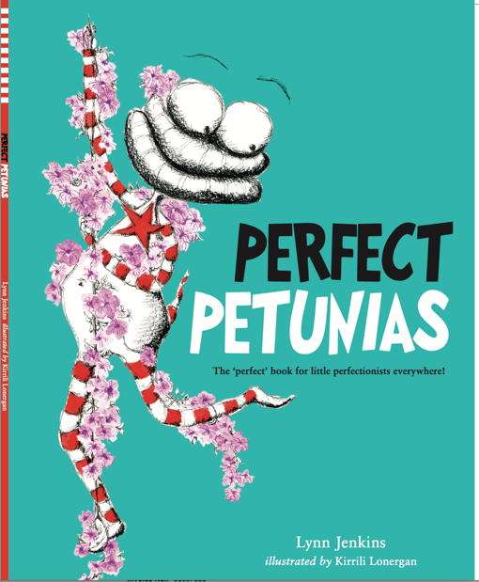

SYNOPSIS:
Loppy is very worried about not doing his homework well enough. He always focuses on what he hasn’t done rather than what he has, and then he becomes very frustrated. So, his friend Curly teaches him about how petunias grow — in lots of different, imperfect directions that he can’t control! Loppy learns that by trying to control whether or not he makes mistakes, it’s as if he’s always trying to grow perfect petunias. Instead, it might be better if he changes his idea of ‘perfect’ to mean trying his absolute best.

THEMES:
Perfectionism, shaping little perfectionistic tendencies, mental flexibility, anxiety, wellbeing, social and emotional wellbeing, dealing with mistakes, perspective, early intervention

SELLING POINTS:
- This book is a must for children, both at home and at school, especially those ones who are prone to worry. Early intervention is the KEY. BUT everyone worries — big or little worries can all be managed the Loppy and Curly way!
- Non-gender specific, appeals to both a national and international market.
- Anxiety and social emotional well-being are very big and topical always.
- The author is an experienced and practicing clinical psychologist and has a clear understanding of the type of issues affecting children.
- It is part of a series that is used to run anxiety management workshops in schools.
- Simple characters that externalise anxiety chatter (Loppy) and it’s management (Curly). They are easy for children to relate to. Simple strategy to manage worries, cognitive flexibility, dealing with mistakes and perfectionistic tendencies.

WRITING STYLE: conversational, educational in the realm of mental wellbeing

ILLUSTRATION STYLE: simplistic, eye-catching, there is continuity to it with the red and white striped tail that flows from page to page throughout the entire book. Packed with visual representations of several emotions and body language.

AUTHOR MOTIVATION: Working for years in clinical practice, Lynn has developed a passion for early intervention. With her knowledge of brain development, she believes it is very important that children receive information about how to manage typical emotional difficulties in an accessible way, so they can grow up with a skill set and the confidence to deal with such issues as they come up in life.

AUTHOR & ILLUSTRATOR BACKGROUND:
Lynn Jenkins
Lynn is an author as well as a practicing clinical psychologist and mum, Lynn is very passionate about assisting children with social and emotional issues via the platform of picture books and their coinciding school visits.
She wrote Lessons of a LAC, Brave and Perfect Petunias — which are the first, second books and third books in a five-book series — to give children a way to think about and manage worry and anxiety. The remaining two will be: Grey Glasses-itis (assisting with mood) and Tree (assisting with loss). A further picture book by Lynn and Kirrili is Ollie’s Treasure, which taps into another of Lynn’s passions — mindfulness.

Aside from writing, Lynn teaches mindfulness (to children and adults), Children’s yoga and counsels children and their parents from her psychology practice – Life Matters Psychologists in Merewether, NSW.

Kirrili Lonergan

Kirrili is a picture book illustrator, a former paediatric nurse and a mother of four. She is currently completing her Diploma in Art Therapy and she is passionately involved in the children’s book community. She has been an active committee member of the NSW CBCA Sub-branch for many years and she volunteers for Book 4 Outback ensuring good quality literature reaches children in outback NSW.

Together, Lynn and Kirrili visit schools to present the Lessons of a LAC Workshops. These workshops extend the lessons in the picture books and leave children with a clear understanding of what anxiety is and a tool-belt of skills to manage it. They believe that EARLY INTERVENTION is the key. They also provide professional development for teachers. Teachers' understanding about anxiety will increase. They will be taught simple techniques on how to manage anxiety in themselves as well as in children. For example, a variety of ways to calmly breathe and relax; mindfulness; self-talk. They will learn to draw emotions and how to teach children how to draw emotions as a way to express themselves. Teachers will generally be made more aware of anxiety in children and in themselves, and be armed with a variety of tools they can use straight away!

INTERVIEW:
AUTHOR
What is the inspiration for this story?
Seeing anxious kids in clinical practice who have a tendency toward cognitive rigidity and the distress it causes them and their ability to move forward in everyday life activities. To give children characters, and their struggles, they can relate to and learn from.

What was the most rewarding part of this project?
Actually seeing the kids relate to it and identify with Loppy’s struggle with making mistakes. Hearing them say ‘My Loppy said …’ and ‘… so my Curly told him to …’

What was the most challenging part of this project?
Probably wording how to relate how petunias grow (i.e. all over the place) with perfectionistic thinking. I had to think about what wasn’t rigid. Once I thought about that idea, petunias naturally came to mind.

ILLUSTRATOR
What media do you use to create your illustrations? Briefly describe your process.
The illustrations were firstly done in ink, colour was added in gouache and then chalk pastels and charcoal were used to finish them off.

What was the most rewarding part of this project?
I really loved bringing the illustrations to life with masses of purple flowers and the finishing touches of the blue butterflies to highlight the important messages.

What was the most challenging part of this project?
I actually don’t feel that there was a challenge. I just loved it!

TEACHER ACTIVITIES/NOTES:
Fits into Mental Health and Well-Being (MH) and Relationships (RS).

- Draw a frame on a piece of paper.. Do a simple drawing BUT go out of the lines with an obvious ‘Oops — I’ve made a mistake’ and keep going. When finished, cover the entire picture EXCEPT the mistake and ask, ‘What can you see?’ Answer: The mistake. Start a conversation about when we overly focus on our mistakes, that’s all we see. Reveal the entire picture and emphasise that by focusing mostly on mistakes we miss out on the many other aspects of the picture.
- Encourage the children to notice the butterflies and ask them to see if there is any pattern to where they appear in the book (they are all on the pages with the main positive messages).
- Create their own Loppy and Curly. Explore how each of them speak. Ask the children to come up with their own Loppy chatter for themselves and their own Curly talk as the alternative. How does Curly respond to anxiety (Loppy chatter)?
- Discuss worry, frustration, calm and happy as feelings in the book. Encourage children to show these expressions on their faces and in their body, and reinforce that when they listen to Loppy they feel a certain type of emotion and when listening to Curly they feel another type of emotion. (ACPPS005)
- Discuss the characteristics of Curly — e.g. kind, helpful, supportive and how they impact on Loppy’s frame of mind (ACPPS006)
- Discuss how the pictures display feelings related to the language. Talk about the language between the characters and discuss what/how feelings and emotions are conveyed. (ACELA1429) (ACELA1787)
- Read the book, discuss how it feels to let your petunias grow and draw a picture of what their world would look like if they let their petunias grow. (ACAVAM106)
- Discuss alliteration and Perfect Petunias as an example.
- Note the punctuation and particularly the exclamation marks and how they are used to convey an emotion (e.g. frustration).
- Read the book and role play the representations of Loppy and Curly — what would Loppy say and what would Curly say? Discuss the differences. (ACELT1580)

